Iteration 1:

y_pred_train = [ 329.148  632.705  431.933  586.411  477.834  394.587  554.057 1002.641

  446.358  457.899  503.029  409.163  324.293  395.85   414.33   471.269

  297.216  560.093  388.602  413.926  363.365  225.349  573.941  901.601

  278.181  307.279  284.656  699.008  633.659  468.654  533.739  341.103

  321.999  314.828  272.375  507.42   538.839  985.438  381.284  323.304

  509.163  584.231  608.609  496.894  291.918  389.119  990.795  351.251

  350.547  344.757  255.305  318.969  404.733  268.952  390.382  348.599

  483.852  399.437  388.294  366.148  765.948  351.975  236.286  183.677

  715.712  366.738  363.91   831.304  292.364  488.817  228.498  474.462

  408.823  463.775  426.997  256.766  537.266  518.716  266.622  362.479

  415.139  325.134  457.205  380.112  500.987  325.908  444.158  586.163

  566.026  722.168  434.904  371.19   555.751  516.805  382.78   393.396

  702.345  379.238  603.629  451.705  665.209  375.949  621.542  196.667

  682.734  346.837  677.541  462.695  494.637  309.1    421.441  522.253

  514.821  499.842  622.383  396.346  244.55 ]

meanSE, medianSE, stdSE, spearmanR = 45225.797659994285 9910.209206006928 103943.23231281759 0.8625437407047328

y_pred_test = [529.905 581.104 580.018 524.758 623.426 572.787 591.457 558.765 591.375

 494.394 481.122 528.04  525.711 549.316 488.647 712.126 519.53  712.049

 600.861 569.667 582.721 530.174 468.652 540.969 542.786 547.165 670.386

 657.263]

Confusion Matrix: 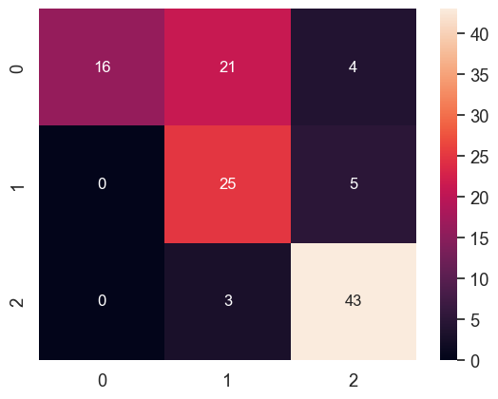

Classification Accuracy = 0.71794871794

Iteration 2:

y_pred_train = [290.395 506.412 433.743 694.657 500.225 392.42  543.661 697.81  635.866

 409.709 642.817 391.141 485.183 413.539 458.43  514.838 285.773 471.595

 432.102 440.063 383.141 385.619 403.542 932.178 268.76  309.129 315.293

 569.758 542.568 413.639 567.393 343.137 363.619 342.282 505.565 386.797

 468.609 744.251 288.651 253.867 545.091 586.996 368.342 402.234 244.939

 382.695 925.08  283.878 321.354 295.569 317.034 289.161 370.067 272.94

 527.746 416.793 450.248 473.885 370.523 315.816 890.634 406.823 261.642

 258.846 666.621 304.126 260.403 772.794 210.593 543.579 313.267 523.885

 461.171 408.24  394.185 233.076 495.483 517.677 324.378 573.81  411.474

 401.431 562.058 336.038 575.605 477.055 473.02  465.128 607.192 896.021

 515.603 302.43  703.636 253.204 351.236 352.518 585.107 364.98  680.333

 532.12  695.292 363.534 578.134 514.744 890.339 397.983 724.51  511.161

 439.271 340.779 376.328 452.986 402.87  254.716 447.601 587.678 276.697]

meanSE, medianSE, stdSE, spearmanR = 45103.446432421806 11742.057141226967 108555.60205888971 0.8689802708232288

y_pred_test = [411.785 398.489 406.977 396.089 383.011 393.531 382.467 382.467 397.569

 391.977 407.051 382.467 395.088 441.52  409.7   456.989 382.467 382.467

 403.637 389.47  721.862 382.105 382.467 568.122 723.858 686.616 383.011

 406.596]

Confusion Matrix: 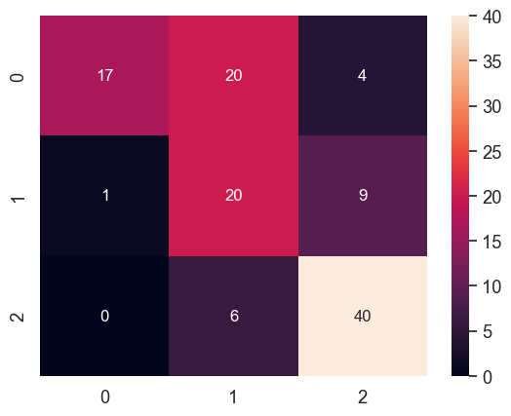

Classification Accuracy = 0.65811965812

Iteration 3:

y_pred_train = [612.589 544.35  658.642 586.923 465.334 346.195 473.575 633.815 491.969

 438.046 590.817 351.028 259.601 411.372 406.738 544.887 363.455 681.447

 427.422 335.319 332.578 377.374 383.996 635.738 374.613 342.122 271.074

 570.251 552.195 615.596 506.556 378.849 257.654 635.519 279.238 631.845

 491.451 813.185 404.615 229.565 595.604 397.656 587.956 314.812 307.998

 367.692 810.367 331.568 343.871 244.02  327.863 275.496 536.224 267.596

 523.963 426.317 485.589 411.649 282.625 386.562 864.611 534.603 210.135

 221.358 676.976 359.113 276.222 790.773 361.739 445.28  305.093 567.269

 487.579 480.879 354.629 262.084 536.859 542.505 369.899 584.542 327.937

 426.957 539.852 293.879 617.01  349.517 357.544 506.476 559.881 737.646

 441.588 401.347 721.329 334.879 288.405 352.845 628.563 357.081 561.317

 489.85  606.529 318.431 509.71  426.293 816.302 450.035 544.613 489.85

 400.43  390.706 374.558 424.474 469.515 334.863 546.328 451.713 302.732]

meanSE, medianSE, stdSE, spearmanR = 55419.69301398347 14694.77577967787 128042.61315599817 0.8476172992507782

y_pred_test = [536.644 526.985 524.382 418.736 504.854 447.262 657.84  651.289 431.7

 662.424 476.182 654.763 572.459 446.234 380.483 591.45  549.684 463.605

 443.36  425.901 487.463 556.297 497.945 481.556 473.976 493.977 562.946

 517.457]

Confusion Matrix: 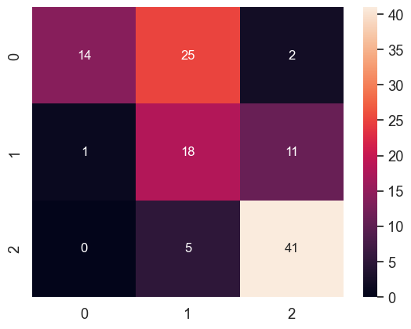

Classification Accuracy = 0.62393162393

Iteration 4:

y_pred_train = [588.421 532.541 669.95  595.332 484.196 352.974 497.432 601.788 545.91

 392.765 637.777 326.257 266.803 393.543 383.336 533.542 397.85  688.146

 340.196 310.86  326.163 527.815 422.814 682.074 297.909 307.755 242.008

 564.342 505.671 587.57  607.929 290.647 325.331 611.815 260.227 612.29

 419.963 699.51  412.979 259.107 562.649 466.204 559.905 335.429 298.097

 406.298 749.568 307.252 328.597 268.21  410.536 223.586 568.997 292.703

 461.165 405.581 586.729 335.554 263.955 288.627 794.689 360.276 261.669

 225.878 731.577 363.256 339.466 704.56  299.53  509.732 222.836 571.208

 500.966 509.464 393.824 411.751 528.431 603.311 304.688 573.547 345.565

 421.742 537.243 277.897 689.75  389.589 361.863 501.845 580.481 698.706

 390.608 343.498 667.424 266.728 278.64  429.055 651.87  494.224 594.12

 480.419 576.324 353.279 576.114 466.389 754.767 434.927 557.397 466.389

 410.891 448.245 331.352 450.436 521.879 305.433 599.542 501.791 305.89 ]

meanSE, medianSE, stdSE, spearmanR = 59309.7075411157 12576.710858053553 147367.1125326709 0.8504890161178985

y_pred_test = [599.992 643.286 480.404 527.493 647.12  560.219 698.557 726.714 574.463

 717.077 443.908 716.539 488.997 525.283 419.902 639.057 614.793 554.892

 554.76  583.087 466.389 471.677 482.768 427.553 489.686 466.389 648.623

 617.636]

Confusion Matrix: 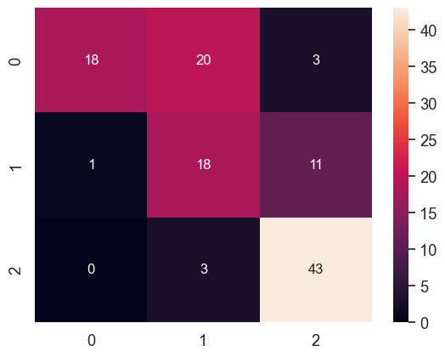

Classification Accuracy = 0.67521367521

Iteration 5:

y_pred_train = [565.249 680.475 627.371 521.677 416.446 465.356 587.918 692.283 581.346

 453.375 722.095 341.072 277.852 421.336 349.311 476.38  366.557 696.669

 389.98  325.991 353.698 371.992 380.121 649.127 340.119 351.045 270.879

 643.844 546.206 692.344 528.879 390.149 288.49  571.663 285.293 709.086

 423.509 711.074 462.326 278.543 552.164 371.98  581.848 246.631 305.457

 355.637 811.459 330.942 427.53  245.257 356.454 251.342 548.314 275.225

 661.275 398.006 519.889 394.235 297.055 390.353 809.933 441.196 218.521

 430.713 609.933 383.628 280.535 791.862 363.655 406.895 325.997 472.877

 372.763 424.014 327.272 275.683 551.371 672.5   281.543 485.332 310.056

 368.587 593.988 315.138 560.1   330.125 328.757 530.391 531.139 640.781

 422.496 341.218 632.734 351.15  298.589 364.703 513.376 342.318 534.747

 598.521 715.206 316.14  496.379 413.279 833.807 537.846 600.579 421.315

 374.215 356.104 328.446 489.61  467.934 346.306 574.523 389.972 333.669]

meanSE, medianSE, stdSE, spearmanR = 59117.64995065265 14560.926483975181 139948.18022438124 0.8167274852803517

y_pred_test = [427.31  428.761 418.722 431.987 556.747 402.639 641.944 631.738 405.622

 754.661 452.434 583.918 680.438 372.83  326.155 505.486 459.409 420.199

 480.243 380.677 414.438 462.883 469.409 523.554 417.277 438.145 405.376

 398.948]

Confusion Matrix: 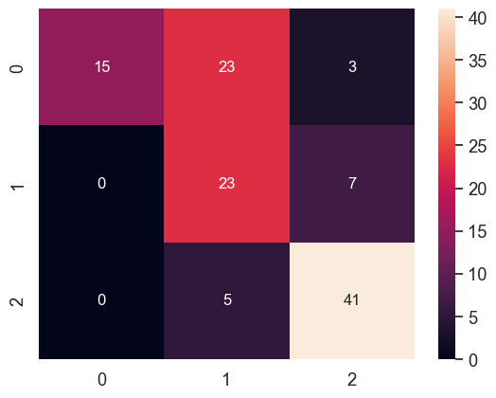

Classification Accuracy = 0.67521367521

Iteration 6:

y_pred_train = [ 446.141  678.725  484.171  552.31   430.55   293.273  444.904  983.327

  480.615  538.099  499.593  394.393  251.822  369.736  396.536  479.608

  314.848  506.497  317.096  426.532  390.515  376.622  445.097 1022.919

  275.126  322.744  340.5    631.681  620.068  514.895  441.837  339.15

  298.37   324.715  397.987  425.619  647.35   815.581  407.023  246.414

  565.031  667.023  610.251  444.159  273.907  408.658  994.764  313.041

  420.492  259.241  278.588  331.366  367.101  287.245  402.667  363.341

  564.056  419.017  396.529  429.664  759.215  375.246  266.965  194.323

  671.909  376.124  270.534  869.182  309.18   410.715  256.285  485.561

  442.199  615.471  307.073  281.244  557.343  483.103  223.473  445.762

  513.274  323.364  461.484  410.956  478.285  394.976  325.17   609.507

  530.607  608.772  463.853  364.922  580.787  421.859  395.903  374.73

  622.357  380.119  591.018  582.973  603.455  427.41   547.635  219.757

  731.153  331.773  514.901  459.37   475.084  278.324  475.523  492.714

  485.502  461.71   524.612  502.17   304.098]

meanSE, medianSE, stdSE, spearmanR = 50780.29177924146 10030.095707902983 119864.37129519529 0.8510981065301083

y_pred_test = [642.275 649.272 602.108 442.236 635.517 533.343 571.602 529.893 510.547

 456.302 559.007 475.518 472.175 546.946 602.053 572.929 574.014 603.102

 486.46  444.192 572.23  438.908 466.456 514.008 518.63  473.884 495.102

 485.906]

Confusion Matrix: 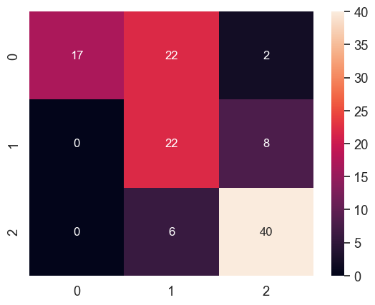

Classification Accuracy = 0.67521367521

Iteration 7:

y_pred_train = [ 299.993  507.585  447.645  675.06   488.965  346.795  504.965  848.758

  557.908  445.952  652.525  364.757  399.48   395.875  435.092  514.577

  274.962  503.99   413.483  373.39   361.02   331.082  429.062 1016.048

  222.528  298.502  201.02   597.258  560.947  453.928  537.202  314.137

  312.755  350.808  420.97   367.235  426.95  1219.755  308.985  176.55

  536.952  570.352  380.752  376.197  212.577  381.75  1239.572  241.02

  357.397  266.038  286.325  200.208  373.467  192.225  496.525  404.665

  474.048  418.02   340.755  256.858 1106.223  392.15   171.39   177.225

  897.518  306.543  230.515  888.153  159.815  536.285  260.11   488.373

  428.038  415.978  376.43   170.005  541.55   529.27   283.29   530.972

  421.745  357.452  503.225  338.5 602.867  413.712  379.88   444.152

  583.74  1019.47   445.408  252.857  627.665  226.308  266.457  344.397

  558.163  398.71   656.11   508.95   817.01   317.183  550.477  330.51

  947.56   329.848  867.952  427.553  322.582  298.66   351.22   426.392

  456.735  209.855  532.055  647.447  256.877]

meanSE, medianSE, stdSE, spearmanR = 19813.632265331198 5331.920400000002 39771.56026138211 0.9578590857249047

y_pred_test = [ 412.908  408.127  418.582  403.498  399.308  403.692  397.072  395.665

  402.512  394.11   400.277  381.375  411.34   433.548  413.678  459.697

  375.61   400.402  402.817  412.16  1119.78   392.945  400.32   574.178

 1154.99   723.08   399.947  407.137]

Confusion Matrix: 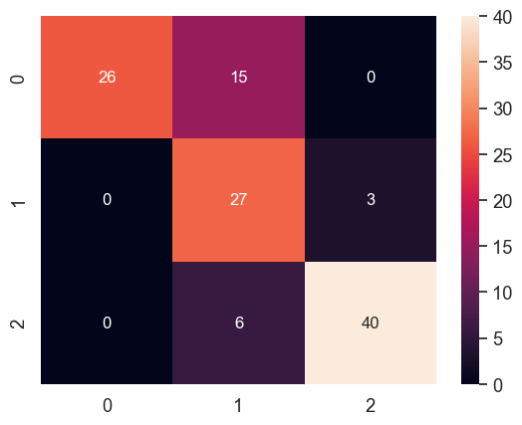

Classification Accuracy = 0.79487179487

Iteration 8:

y_pred_train = [364.265 624.94  431.564 559.963 497.502 403.833 572.122 777.395 535.511

 452.969 614.356 300.571 228.162 599.687 438.694 492.023 317.213 526.155

 348.312 345.985 407.343 250.162 371.926 777.401 384.012 501.835 437.274

 624.292 512.05  493.917 456.379 303.436 366.869 471.083 284.559 433.552

 353.156 878.222 414.821 244.908 497.179 817.441 476.364 212.829 283.9

 291.72  869.66  291.431 500.436 250.294 324.137 296.309 458.423 268.029

 486.021 521.034 486.324 459.484 403.565 206.598 763.75  465.512 215.959

 259.895 648.86  303.467 429.5   917.461 333.255 746.961 280.863 488.994

 437.843 455.869 430.981 176.867 678.663 743.619 293.427 516.405 417.9

 399.996 561.367 311.254 589.676 408.196 385.301 348.645 570.266 744.188

 459.511 441.791 538.327 287.788 314.503 255.223 497.722 403.001 615.45

 528.244 748.186 269.925 530.133 300.856 528.088 254.487 710.766 412.607

 457.842 367.114 370.597 660.799 414.053 244.315 619.529 500.39  268.968]

meanSE, medianSE, stdSE, spearmanR = 50921.94049700074 13475.30180736852 125206.79090963678 0.8642746353000443

y_pred_test = [312.628 559.29  571.787 325.205 344.386 329.765 376.604 476.437 715.955

 345.637 498.555 345.332 538.862 556.775 674.062 657.569 374.783 476.286

 441.174 371.397 663.356 726.614 348.793 716.023 734.868 766.257 780.172

 312.858]

Confusion Matrix: 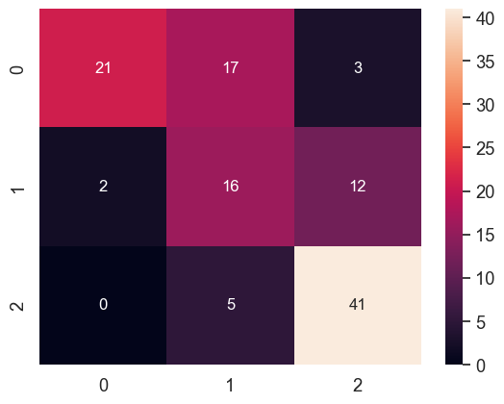

Classification Accuracy = 0.66666666666

Iteration 9:

y_pred_train = [666.857 519.844 700.744 554.645 442.49  324.116 465.27  594.738 526.208

 466.153 594.848 373.413 256.588 371.206 342.422 523.107 391.212 706.343

 401.696 329.837 336.37  425.121 375.103 627.637 380.071 368.11  276.197

 550.198 535.394 636.094 507.604 439.503 283.689 687.835 289.752 673.343

 496.567 731.963 392.327 233.727 570.156 416.107 568.173 266.453 331.486

 345.571 759.504 321.003 332.186 269.744 373.569 251.145 568.091 302.669

 496.494 461.148 504.322 367.742 297.128 393.028 818.106 512.353 209.156

 226.596 669.694 368.072 332.332 728.267 343.926 468.015 320.433 496.434

 455.613 468.517 371.484 321.741 582.833 529.777 387.542 537.758 311.163

 460.348 459.269 295.072 616.988 387.246 345.287 422.895 497.855 695.777

 447.147 372.275 695.268 289.997 272.373 418.15  601.109 361.989 558.938

 473.638 591.223 320.895 504.999 473.638 782.804 477.275 545.397 473.638

 401.506 380.739 354.648 462.43  463.98  343.047 575.072 448.131 311.527]

meanSE, medianSE, stdSE, spearmanR = 62411.821063631796 13017.336893396563 144174.1409060217 0.8159093633856852

y_pred_test = [517.137 544.744 497.05  441.108 532.298 401.26  699.861 700.632 392.439

 698.258 502.316 694.959 576.088 460.382 414.239 578.452 520.203 419.604

 434.519 453.863 473.638 539.074 483.472 444.239 485.628 473.915 537.977

 520.327]

Confusion Matrix: 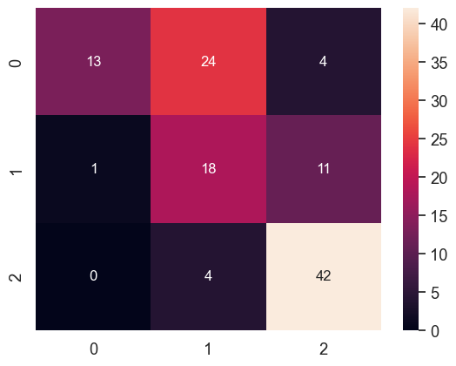

Classification Accuracy = 0.62393162393

Iteration 10:

y_pred_train = [ 352.172  772.967  513.893  501.163  422.996  302.393  485.984 1014.329

  482.527  529.442  470.888  389.127  285.546  434.165  398.058  479.853

  299.093  469.304  360.264  457.239  412.271  306.923  501.841  946.347

  300.426  280.738  351.52   787.293  691.892  500.472  407.226  312.573

  258.484  310.574  282.422  414.616  508.251  902.433  404.601  296.627

  542.753  580.42   566.92   483.644  247.696  356.971  968.194  291.67

  407.812  268.396  278.265  355.968  391.102  259.265  398.836  373.155

  517.007  399.094  387.69   470.727  819.346  334.696  267.646  218.714

  684.795  354.837  311.671  812.239  277.612  459.852  227.027  494.188

  414.599  625.023  404.221  251.796  566.315  514.733  248.456  445.215

  441.855  347.934  409.185  420.535  473.814  398.669  390.945  507.425

  545.446  650.424  449.576  343.593  565.286  434.592  365.866  367.343

  645.718  342.292  573.029  563.461  594.563  422.077  627.732  255.341

  779.187  326.832  543.667  439.141  468.037  267.518  471.15   513.802

  517.404  494.35   517.381  485.918  317.874]

meanSE, medianSE, stdSE, spearmanR = 48280.59435955529 11332.84747088101 110203.858288049 0.8550057322074024

y_pred_test = [445.398 494.827 467.057 427.006 485.165 441.144 429.773 431.077 454.082

 394.856 454.908 393.959 383.342 476.872 396.51  687.968 441.757 554.356

 459.752 441.757 608.436 379.974 379.09  467.838 475.112 436.962 444.908

 447.332]

Confusion Matrix: 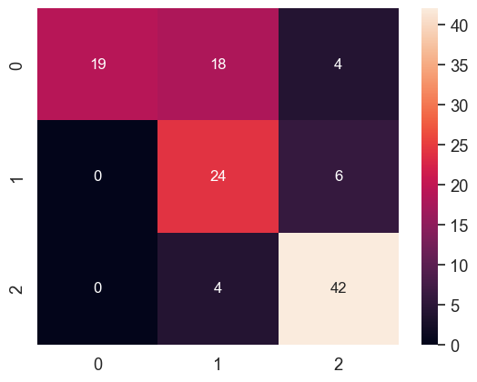

Classification Accuracy = 0.72649572649